
NORTHERN EDUCATION DIVISION MOCK EXAMINATION
2026 MALAWI SCHOOL CERTIFICATE OF EDUCATION
AGRICULTURE
Tuesday, 17th March Subject Number:M012/I
Time Allowed 2 hours
08:00-10:00 am
PAPER I
(100 MARKS)
Instructions

- This paper contains 12 pages. Please check.
- This paper contains two sections, A and B. Section A has ten questions and section B has three questions.
- Answer all questions in the spaces provided.

- Write your name in the spaces provided on top of each page of this question paper.

- Use of scientific calculators is allowed

- In the table provided on this page, tick
against the question number you have answered.

- At the end of examination, hand in your paper to the invigilator when time is called stop writing

Question Number | Tick if answered | Do not write in these columns
1
2
3
4
5
6
7
8
9
10
11
12
13

©NED MOCK Turn over

Section A (70 marks)
Answer all questions in the spaces provided
- a. Mention any two activities involved in processing maize.
___________________________________________________________________________________________________________________________________ (2 marks)
b. State any two aims of crop improvement.
____________________________________________________________________________________________________________________________________ (2 marks)
c. Explain any two disadvantages of vegetative propagation.
__________________________________________________________________________________________________________________________________________________________________________________________________________________________________________________________________________________________________________________________________________ (4 marks)
d. State any two factors that affect soil depth.
____________________________________________________________________________________________________________________________________ (2 marks)
- a. Mention any two principles of grazing management.
____________________________________________________________________________________________________________________________________ (2 marks)
b, Explain any two ways in which food fortification is important. i.___________________________________________________________________________________________________________________________________ ii.__________________________________________________________________________________________________________________________________ (4 marks)
c. Outline any two disadvantages of hybridisation in agriculture.
i.__________________________________________________________________________________________________________________________________ (2 marks)
- a. State any two livestock breeding systems.
____________________________________________________________________________________________________________________________________ (2 marks)
b. Explain any two importance of steaming up in nannies.
i.___________________________________________________________________________________________________________________________________ __________________________________________________________________
ii._________________________________________________________________ ____________________________________________________________________________________________________________________________________ (4 marks)
c. Explain any one cultural measure of controlling soil degradation.
____________________________________________________________________________________________________________________________________ (2 marks)
d. Define a feed ration.
____________________________________________________________________________________________________________________________________ (1 mark)
- Figure 1. is a diagram showing a process on the farm. Use it to answer the questions that follow.
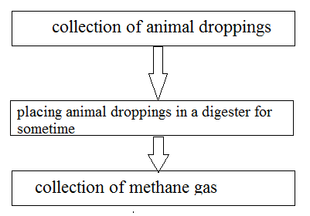Figure 1
- Name the process in figure 1.
__________________________________________________________________
(1 mark)
- Explain any two ways in which the process mitigates climate change.
____________________________________________________________________________________________________________________________________________________________________________________________________________________________________________________________________________________________________________________________________________________________________________________________________________ (4 marks)
- Figure 2. is a diagram showing a source of farm power. Use it to answer the questions that follow.
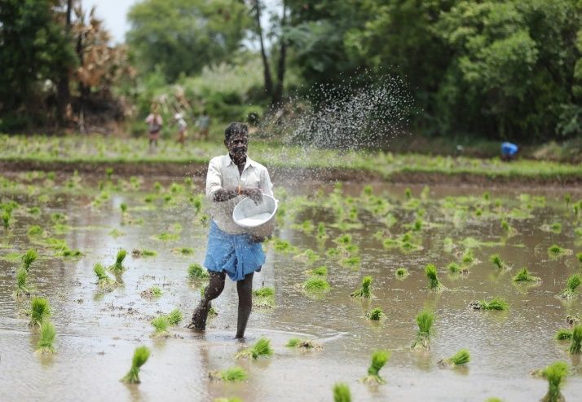 Figure 2
- Identify the source of farm power.
__________________________________________________________________ (1 mark)
- Explain any two ways of improving the workforce for the farm power in 5(a).
________________________________________________________________________________________________________________________________________________________________________________________________________________________________________________________________________ (4 marks)
- Explain any two effects of gender biases in agricultural technology.
__________________________________________________________________________________________________________________________________________________________________________________________________________________________________________________________________________________________________________________________________________ (4 marks)
- a. Describe any one factor that affects the rate at which animals reach puberty.
____________________________________________________________________________________________________________________________________ (2 marks)

Table 1 shows a farm record kept by a farmer. Use it to answer question 6(b).
Table 1
Price of rice(MK) | Variable costs(MK) | Fixed costs (MK)
5000 | 340 000 | 40 000

b. Calculate the amount (kg) of rice the farmer has to produce in order to start making profits.

(3 marks)
- a. Explain any two ways farmers deal with risks and uncertainties in agricultural production.
________________________________________________________________________________________________________________________________________________________________________________________________________________________________________________________________________________________________________________________________ (4 marks)
b. Figure 3 shows a parasite in livestock production. Use it to answer the questions that follow.
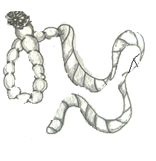 Figure 3
i. Identify the parasite.
__________________________________________________________________ (1 mark)
ii. Mention one way in which the parasite affects the livestock production.
__________________________________________________________________ (1 mark)
iii. Give one way of controlling the parasite.
__________________________________________________________________ (1 mark)
- a. Define progeny testing.
____________________________________________________________________________________________________________________________________
(1 mark)
b. Figure 4 is a livestock reproductive system. Use it to answer questions that follow.
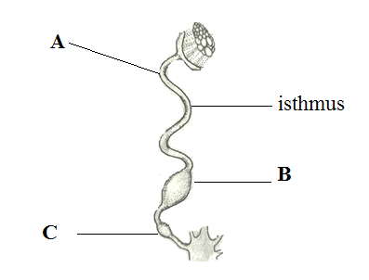Figure 4
i. Name any one livestock that has the above reproductive system.
__________________________________________________________________ (1 mark)
ii. Give any two functions of the part labelled C.
____________________________________________________________________________________________________________________________________ (2 mark)
c. State any two situations that require a complete budget on the farm.
____________________________________________________________________________________________________________________________________ (2 marks)
- a. Give any one way in which inoculation of pasture seed is important.
___________________________________________________________________________________________________________________________(1 mark)
b. Table 2 shows marketing costs for pineapples. Use it to answer questions that follow.
Table 2
Marketing channel | Charges (MK) | Market Price(MK)
1. Farmer | - | 10000
2. Middleman  Transport  Profit | 5000  2000 | 17000
3. Processing company  Processing  Canning  Profit | 12000  10000  8000 | 47000
- Retailer  Transport  Advertising  Profit | 5000  5000  20000 | 77000
i. What type of marketing channel is presented in the table 2?
_________________________________________________________ ( 1 mark)
ii. Calculate the marketing costs for the retailer

(2 marks)

iii. Calculate the total marketing margin for the whole marketing channel.

(2 marks)
- a. What planting materials are used to propagate following plants asexually?
i. Ginger
________________________________________________________________ (1 mark)
ii. sisal
________________________________________________________________ (1 mark)
b. Give any two risks and uncertainties currently affecting maize farmers in Malawi.
______________________________________________________________________________________________________________________________________________________________________________________________________ (2 marks)

SECTION B (30 Marks)
Answer all questions in an essay form.
- Explain any five factors to consider when selecting livestock for breeding.
________________________________________________________________________________________________________________________________________________________________________________________________________________________________________________________________________________________________________________________________________________________________________________________________________________________________________________________________________________________________________________________________________________________________________________________________________________________________________________________________________________________________________________________________________________________________________________________________________________________________________________________________________________________________________________________________________________________________________________________________________________________________________________________________________________________________________________________________________________________________________________________________________________________________________________________________________________________________________________________________________________________________________ (10 marks)
- Explain any five ways in which agroforestry deals with climate change.
__________________________________________________________________________________________________________________________________________________________________________________________________________________________________________________________________________________________________________________________________________________________________________________________________________________________________________________________________________________________________________________________________________________________________________________________________________________________________________________________________________________________________________________________________________________________________________________________________________________________________________________________________________________________________________________________________________________________________________________________________________________________________________________________________________________________________________________________________________________________________________________________________________________________________________________________________________________________________________________________________________________________________________________________________________________________________________ (10 marks)
- Describe any five effects of population distribution on marketing of tomatoes.
__________________________________________________________________________________________________________________________________________________________________________________________________________________________________________________________________________________________________________________________________________________________________________________________________________________________________________________________________________________________________________________________________________________________________________________________________________________________________________________________________________________________________________________________________________________________________________________________________________________________________________________________________________________________________________________________________________________________________________________________________________________________________________________________________________________________________________________________________________________________________ (10 marks)
END OF QUESTION PAPER
This paper contains 12 printed pages

